Team Practice Emergency Action Plan
A central purpose of this is to help teams plan ahead and manage potential risks.

Location / Park Name | Lone Lake: 5624 Shady Oak Rd, Minnetonka.  PARK @ Shady Oak Beach: 5200 Shady Oak Rd, Hopkins
- In the event of a serious injury, always call 911 first. | - Check the weather forecast before every practice.
Lead Coaches [name & cell #] | Head Coach: Mike Hartmann (612) 308-8665  Performance: Jeff Jackson (715) 492-0738  HS-Adv: Bob Vose (612) 481-3210 Erik Hinkie (612) 860-2606  MS: Emily Hoppe (952) 239-5097
Closest Hospital(s) and anticipated time to each from least-accessible location | Fairview Southdale Hospital. 6401 France Ave S. Edina. 15 min.  AFC Urgent Care: 415 17th Ave N, Hopkins. 8 min.  Minnetonka Fire Dept Station 3: 5700 Rowland Rd, Hopkins
Trails to be avoided by some or all ride groups (note concerns) | Trails accessible to all riders at appropriate speeds. Moderate elevation and some tight and off-camber turns.
Location Emergency Responder Contact Info [park police, park ranger, town police | 911
Access Points for Emergency Access or Transport [describe and include on map] | Two main parking lots / access points for emergency vehicles. Main parking lot (5624 Shady Oak Rd). North Side of park.  Small parking lot: 5795 Rowland Rd, Hopkins
Water Refill and Shelter locations. | Water refill at main trail. Bathrooms near tennis/pickleball.
Other Park-specific Info | Team needs to ride from Creek Valley (3.5 mi ride) or Park at Shady Oak beach (.25 min ride along paved bike path to main parking lot). MAX 40 athletes/coaches on dirt trail at one time.  Great access to short or medium paved trail loops or down-back. Access crushed gravel LRT trail via Rowland. Sufficient shoulder along Rowland, but use caution with beginner riders.
Maximum time to evacuate the trail due to weather. | 2 minutes to Creek Valley school

Short, paved path connecting main trail and 1 mile loop
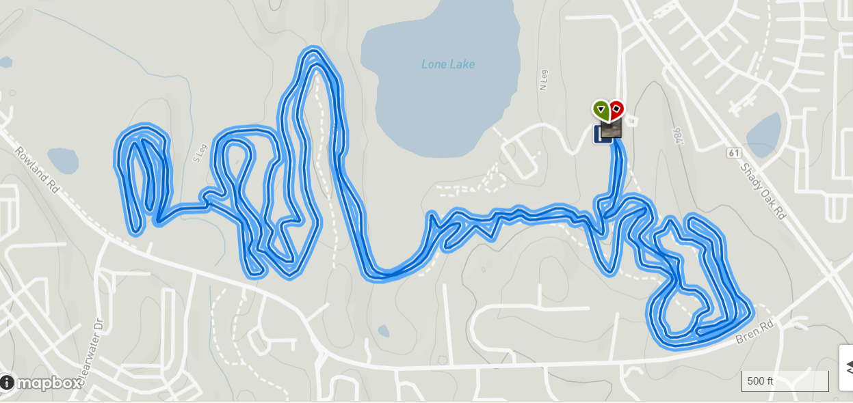
Small parking lot
P

