Hyland Reserve (10145 Bush Lake Rd, Cross Country Ski trailhead)
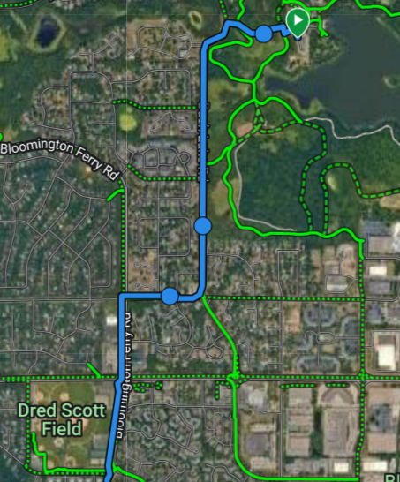
River Bottoms -> Xcel Mtb Park. Detailed RB Sections at the Bottom.
Route: Hyland Park Reserve (CC Ski trailhead) to
River Bottoms: 2.4 Miles.
Left onto Bush Lake Rd ->
Right onto W 106th St ->
Left onto Bloomington Ferry Bridge Rd (4 way stop)
Past Dred Scott Park -> Bloom Ferry Bridge Rd curves right, down the hill into the Trailhead Parking Lot.
Access River Bottoms offroad trail to the left, before crossing the River Bridge.

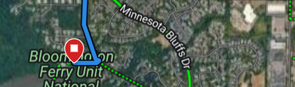

River Bottoms Trailhead (Bloomington Ferry Bridge to Xcel Mtb Park = 4.1 Miles
- Follow the paved path over the river, along Hwy 101 to Stoplight at Valleyfair.
- Cross Hwy 101 and turn left onto Innovation Blvd all the way to Xcel Trailhead.

Hyland to Xcel Mtb = 6.5 Miles. 15 Mile Roundtrip + any offroad sections.

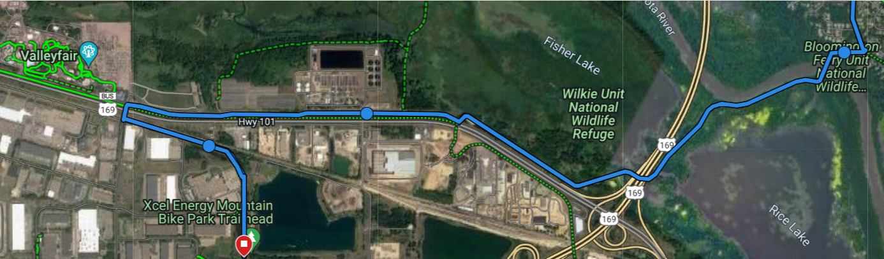

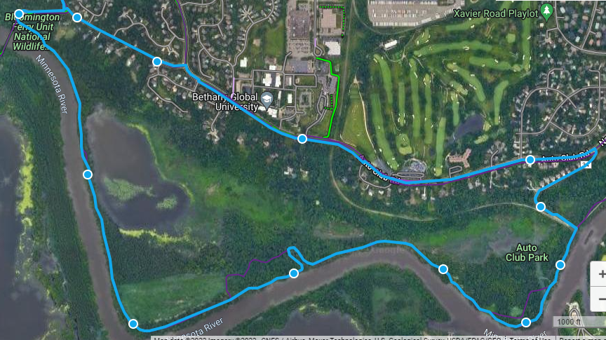
RIVER BOTTOMS SECTIONS: Start at Bloomington Ferry Bridge (furthest West)
Option #1: To “Swing Bridge” = +/- 3 Miles. Either double back on trail or exit to residential area and take Auto Club road back to Bloomington Ferry Rd (shown in the 1st RB map below?
Option #2: Continue another mile along RB trail to exit #2. Very challenging hill climb to exit onto Overlook Road. Either double back on trail or exit onto Overlook. Left on Overlook -> Left onto Normandale which turns into Auto Club Rd. Follow back to Bloomington Ferry Rd. Map #2 Below.

River Bottoms Option #2 Map
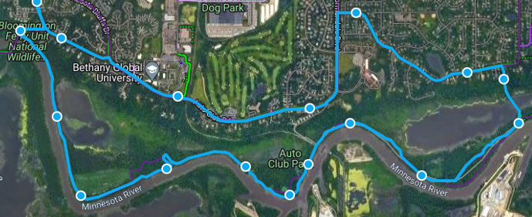

Option #3 (Performance Only?): This is only for groups able to cover a LONG distance ride. This is probably 21 – 25 miles depending on how far East of 35W you go.
River Bottoms to Exit #2 and continue East to 35W River Bottoms. 9.45 Mi to parking lot. Explore East of parking lot as time allows.
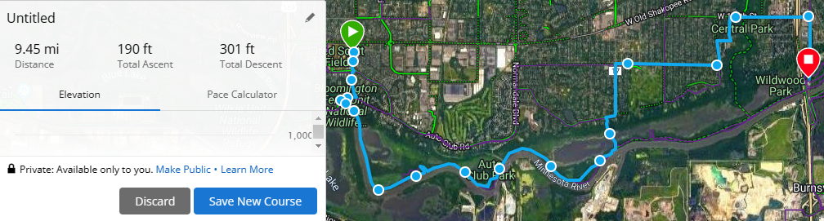
The River Bottoms continues East of 35W. The further North / Away from the river, the more elevation change. I’m not as familiar with this section. The distance from 35W parking lot to Indian Hills Park is about 3 Miles. Example below.
