Creek Valley – Ice Cream Ride – 9 Mile Creek South = 5.25 Miles
Add Bredesen Loop for + 2.25 Miles

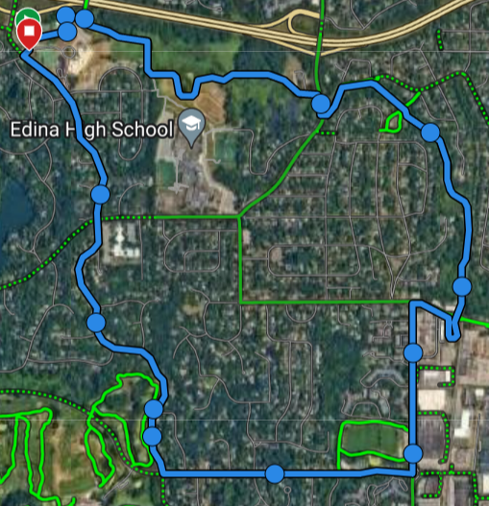
Gleason
Dewey Hill Rd
Cahill Rd
W. 70th St
9 Mile Creek Bike Path

