CREEK VALLEY ELEMENTARY SCHOOL PARK
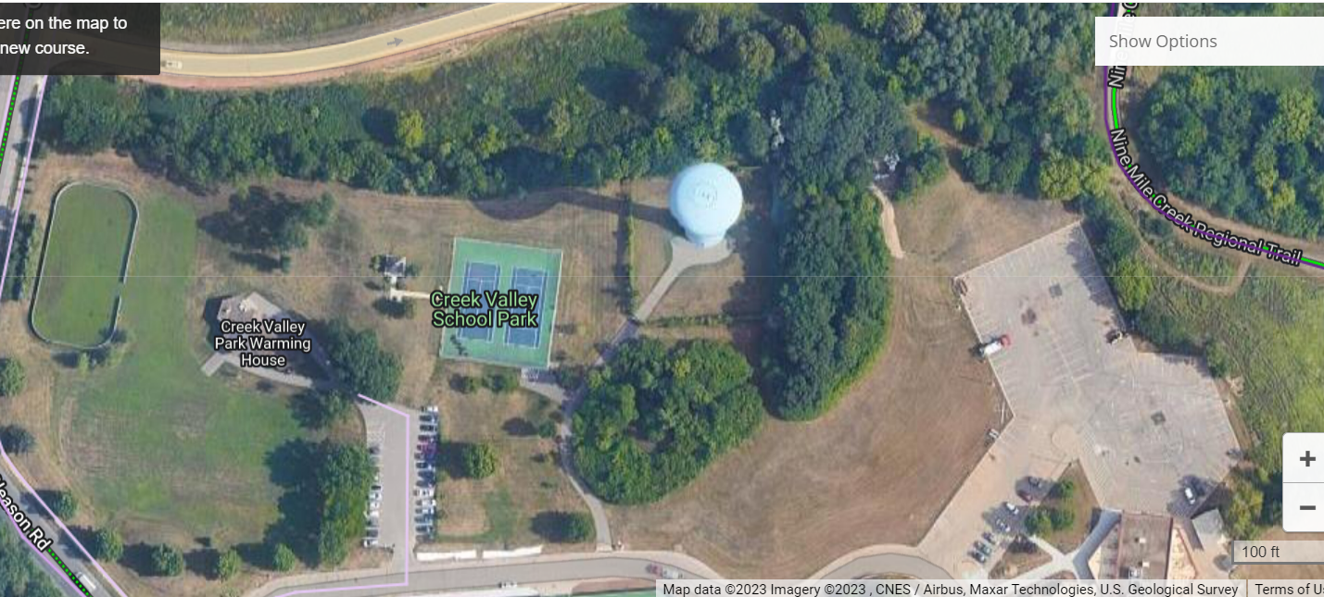
Great for Hill Repeats. Team Strava segment??

Park here

Short-track Start/Finish.

Location: Meeting area in green space near warming house. Park in the back of the school lot (NOT by the tennis courts).
This meeting location provides areas of flat open space in addition to some nice topography to create various Short-Track courses and skills practicing areas.

There is also great access to 9 Mile Creek Regional Trail, Bredesen Park, Breamar along with great hills in the Indian Hills neighborhood.
Lone Lake = 4.0 miles direct route. See route below.
River Bottoms = 8.0 Miles. 4.5 Miles from Bloomington Ferry Bridge Parking lot to Xcel Mtb Park (12.5 Miles from Creek Valley).
Short-Medium-Long Track Courses: Many options including a great training hill on the NE corner of the park back in the woods. Ideal for building in skills practice in a trail environment where coaches can observe along with “fun” interval and hill training.
Zoomed out view. EHS accessible by 9 mile creek just to the East. Bredesen just across Hwy 62 on 9 mile creek path.

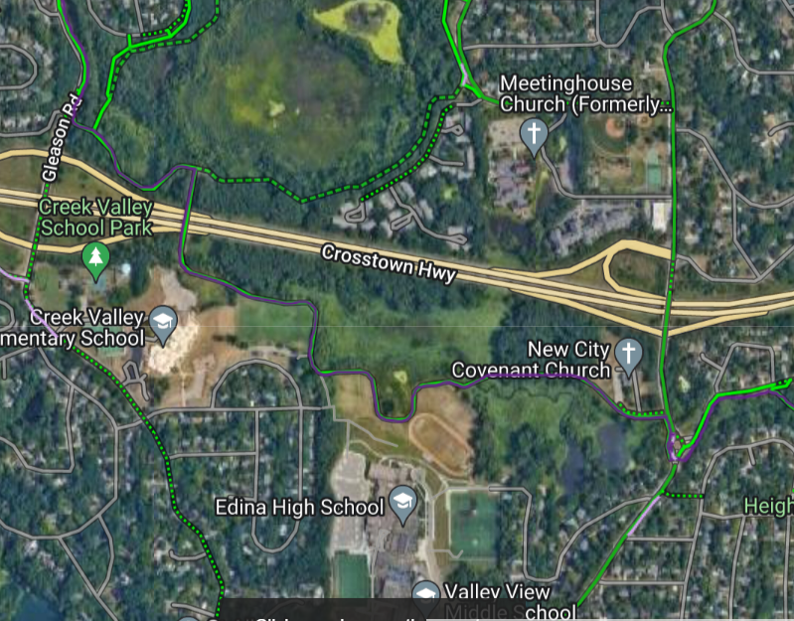
Direct Route: Creek Valley Park to Lone Lake Trailhead (main parking lot).
9 Mile Creek cuts through Bredesen -> goes underneath hwy 169 and connects to Smetana. Smetana is a straight shot to Shady Oak.
