2023 RACE WEEKEND – ZOOM MEETING

2023 Mid-Season Overview and House Cleaning.

GREAT Start to the Season!!
Finding our Groove and the Stoke is High.
Thank You Coaches. Thank You Parents. Thank You Athletes.

Team App Practice Sign-up has improved SIGNIFICANTLY.
One Tip / Trick that has been learned:
Parent/Child “connection” in Team App can cause some Coach confusion.

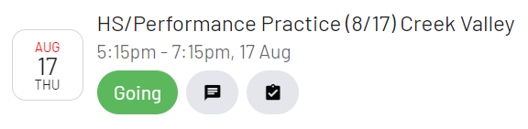

View from “Events” List page:

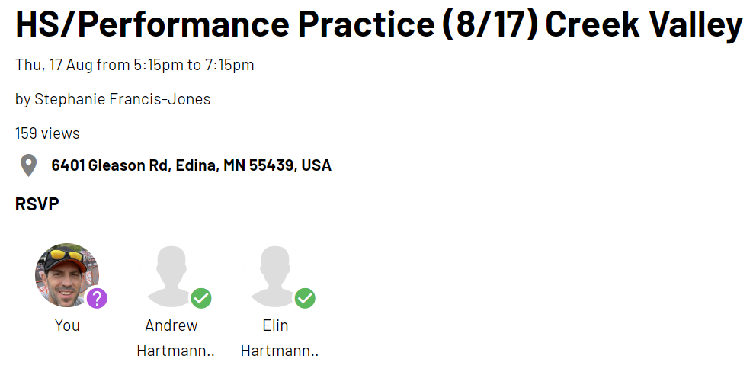

Actual Event Attendance:

KEY REMINDERS:

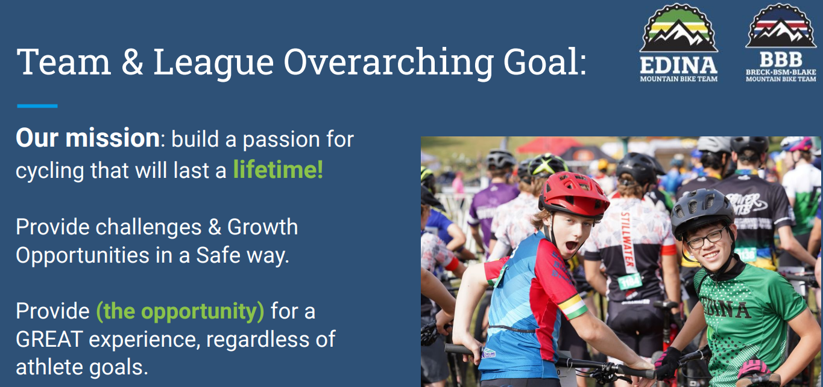

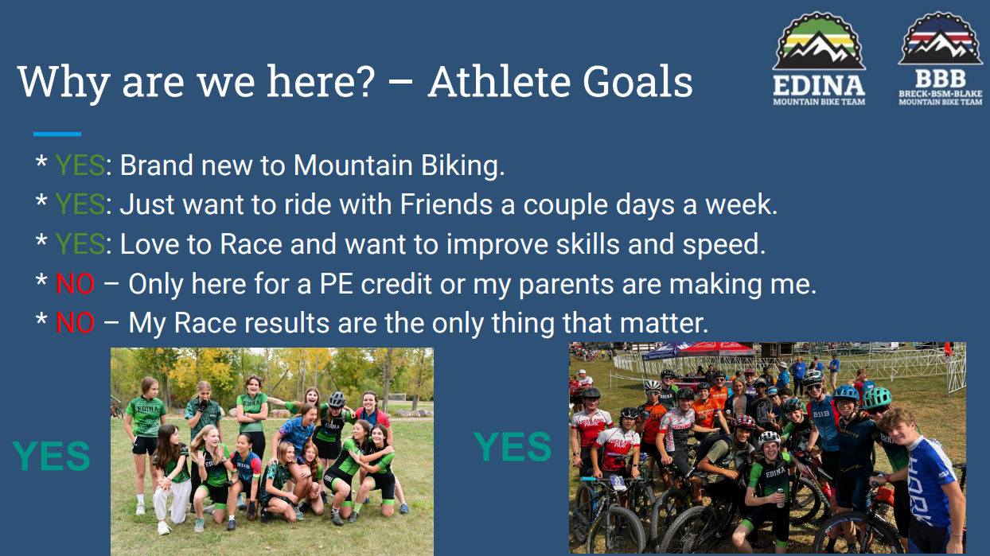

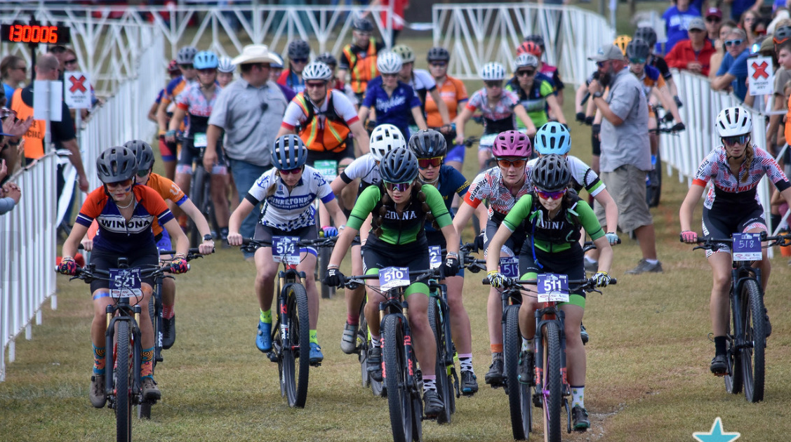
LET’S GET STARTED

RACE WEEKEND – Team OVERVIEW:
- Team: 121 Registered athletes; 109 racing.
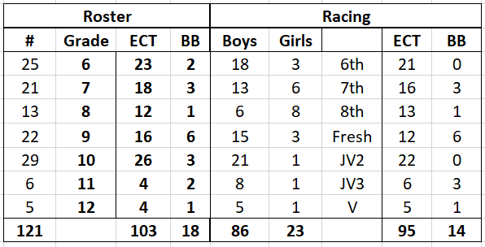

RACE REFERENCE MATERIALS – PLEASE REVIEW THESE MATERIALS.
MN Cycling Assoc. Website: https://minnesotacycling.org.
Specific Race Details-> 2023 Racing Series-> Select the specific Race.
- Race Venue specifics (Parking, race course detail, etc.)
- Race Weekend FAQ – really good reference.
- League emails (league director: Josh Kleve). Sign-up if you aren’t receiving.
- Weather Alerts: Recommend signing up. Have to sign-up each year. Website link allows selection by race. Email outlines text to sign-up option.
- Race results (unofficial): www.precisionrace.com/mca

RACE WEEKEND Logistics:
Race Plates: Athlete keeps remainder of the year. Available at race venue.

Pre-Ride: Highly recommended (but remember the intent)
Friday after 4:30 to sunset. Must coordinate with a coach & have plate.
Saturday 7:30- 11:30 (last rider on by 11:00), after MS done (4:30ish)
Sunday until 7:30 am (last rider on the course by 7:00)

*If you can’t make the pre-ride, check out course preview YouTube videos. Schindler’s Way

- Race/Coach plate & with a coach required. Will be available at the team Tent Saturday morning for the preride. Coordinate with Mike if pre-riding Friday.

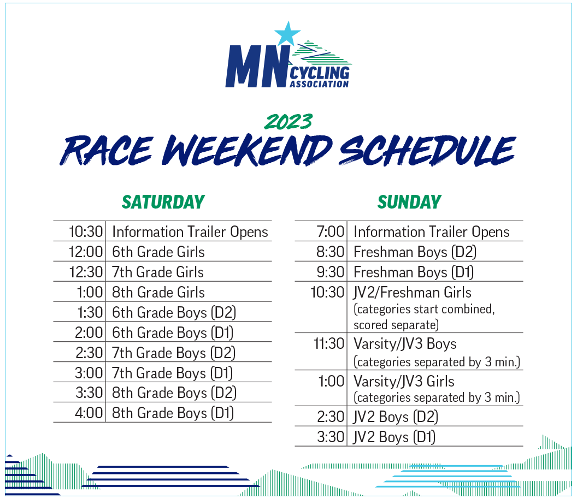
NOTE: Final Race / State Championship will have a different schedule.

D1 - D2: Divisions based on size of HS category racers. ECT = D1. BB = D2.
MS: Saturday: All MS races on Saturday are 1 lap.
HS: Sunday: Freshman & JV2 = 2 Laps; JV3 = 3 Laps; Varsity = 4 Laps.

Race Details: Above times are race START times.
- Staging: get to start 15 MINUTES prior to start to get lined-up. Names called 10 minutes before start. Miss your name = back of the wave.
- Staging Order = “Call-ups”. Determined based on previous results. 6th graders are randomly assigned. If no prior race history, will be placed at the back.
- Warm-Ups (Coach or Captain): Team will organize warm-ups and timeliness to staging for each race category.

Warm-ups: TeamApp “Duty Roster” / Sign-up. Duty Roster-> Assign to me
1) Get legs and lungs ready. Generally— Slow start (5ish minutes) -> Ramp up pace gradually -> Couple hard efforts (20-0 seconds) -> Ramp down to easy pace. But riders should consider personal warm-up needs (some need longer/slower, some need a couple of 100% efforts, etc.)
2) Bathroom break / drop extra items as needed. Can’t drop or accept items once lined up.
3) Get to Staging on time!!

Requirements to Race: 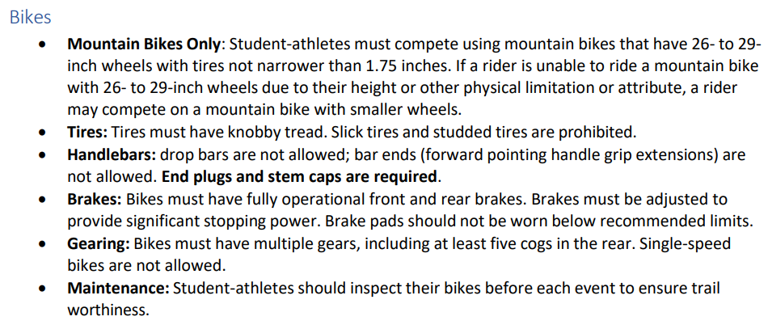
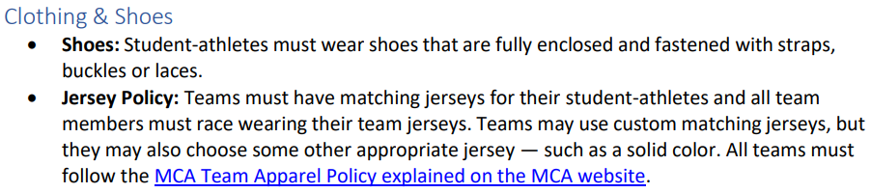
Race Venue Infield (Team Tents):
- Team will have 2-3 tents, changing tent, bike racks, stand & tools.
  - Tent location determined by the league; will forward map when available. League also posts on social media.

Volunteer Opportunities: Team & MCA. Adults & Athletes
https://www.signupgenius.com/go/10C0E4AA4AE2DAAFBC52-2023
Team:
1) Gear Transportation (Tents, Tables, Tools, Cooler)
2) Set-up / Take Down
3) Photography
4) Food & Drink
5) Team Tent support
These are the tasks that facilitate a good weekend of racing!

Photo curator on TeamApp - Good role for an athlete

MCA: See MCA website race flyer. Ex. Course Marshall, Crossing Guard, Call-ups… Athletes eligible for some roles. Hours qualify for Team volunteer hours.

Feed Zone: Available for multiple lap races, if desired. Athlete to coordinate with coaches. Notify Jeff, Bob or Mike.

Skills Area: MCA will have obstacle course set-up to work on bike handling skills.

Awards Ceremony: No league awards ceremony.

Spectating: Location: Check out to course map to look for good spots.
- Good Sportsmanship
- Do not lean over race course tape. Do not cross under or over race tape.

OTHER RACE WEEKEND ITEMS:
Neutral Support: TBD if LBS mechanic on site. MAKE SURE BIKE IN GOOD WORKING ORDER PRIOR TO COMING. Team will have basic supplies and do its best, but should not be relied on for race day repair work.

DNF or Outside Assistance: Let a coach or league official know.
- DNF = Did not finish
- Outside Assistance: Athletes need to fix any mechanical. Time penalty if outside assistance. Doubles if unreported.

Tips:
- Make a Packing List and review before leaving for each race.
- Bring a change of cloths and stay for the day. Hammocking, cheering with teammates and getting to know athletes from other teams.
- Hydrate the day before and day of.
- Nutrition: bring any specific / desired energy, food, and drink. This is the day to eat and drink healthy.

Highlights from MCA Website / Race Regulations:
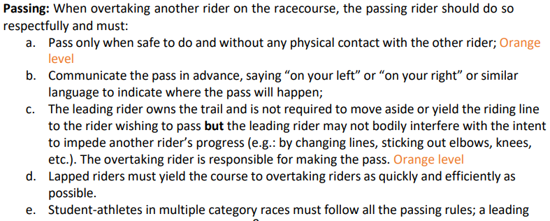
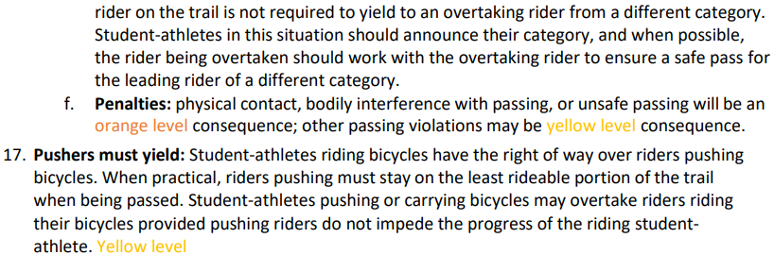

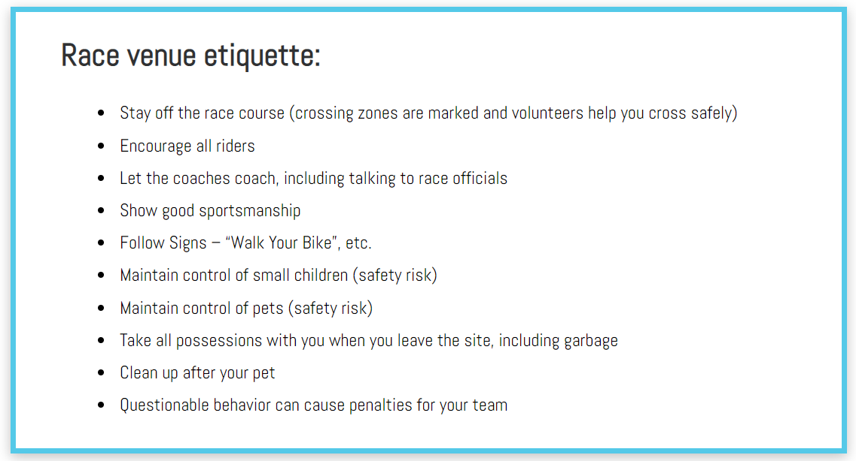

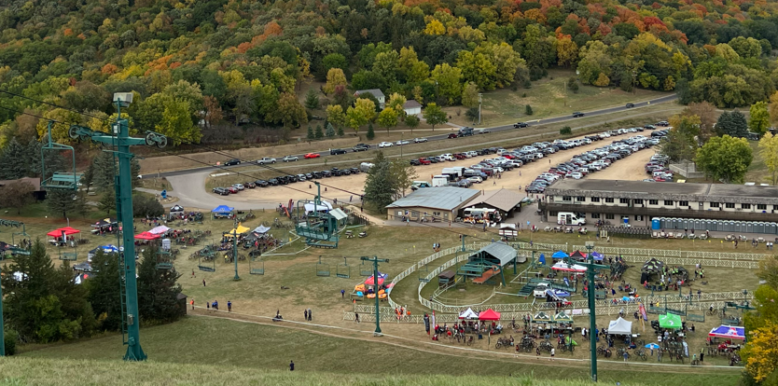
?? QUESTIONS ??

RACE PREPARATION
!! Good Night Sleep !!
!! Good Nutrition and Hydration - Day before, Day of !!
!! Easy Spin Day before
!! Have Fun. Everyone experiences “Nerves”. Natural, Normal and a Good Thing. Use that Energy…

Race #1 Specifics – Austin MN (Schindler’s Way)
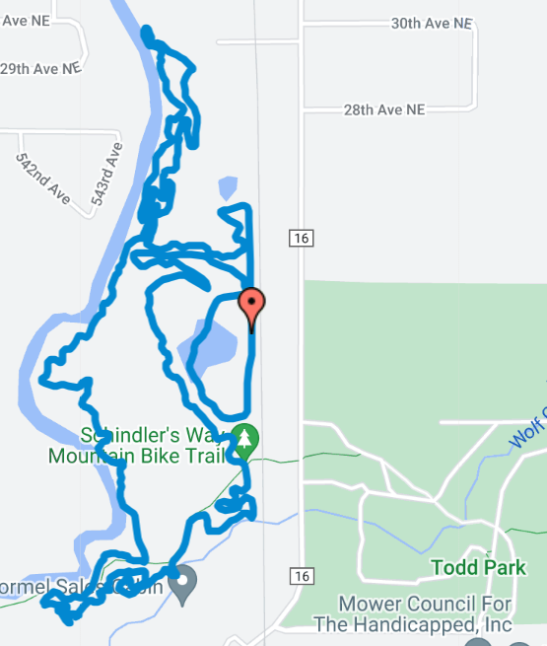
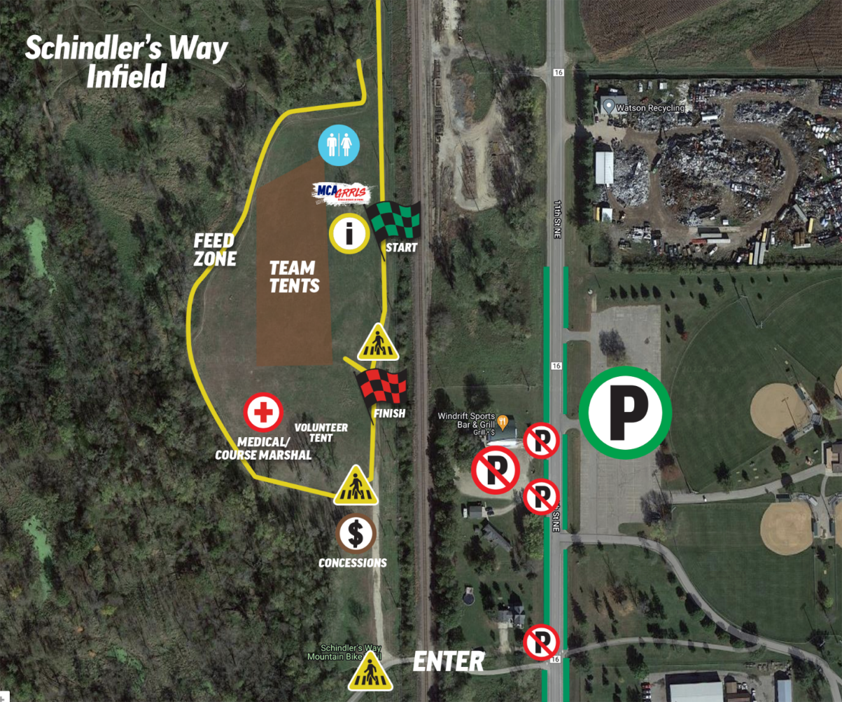
Race Course Description:
3.75 mile loop.
Very little elevation change.

